UNION/INTERSECT/EXCEPT
lundi 4 novembre 2024
14:07

  - SELECT 1

  - SELECT 1 AS col1

  - SELECT 1 AS col1, 'A' AS col2

  - SELECT 1 AS col1, 'A' AS col2
UNION
SELECT 2 as col1, 'B' AS col2

  - SELECT 1, 'A'
UNION
SELECT 1, 'A'

  - SELECT 1, 'A'
UNION ALL
SELECT 1, 'A'

  - SELECT 1 AS A
UNION
SELECT 'A'

  - SELECT 1,2
UNION
SELECT 3

  - SELECT 1,'A'
UNION
SELECT 1, NULL

  - SELECT 1 UNION SELECT 1 UNION SELECT 2

  - SELECT 1 UNION ALL SELECT 1 UNION SELECT 1

  - SELECT 1 UNION SELECT 1 UNION ALL SELECT 1

  - SELECT 1 UNION ALL SELECT 1 UNION ALL SELECT 1

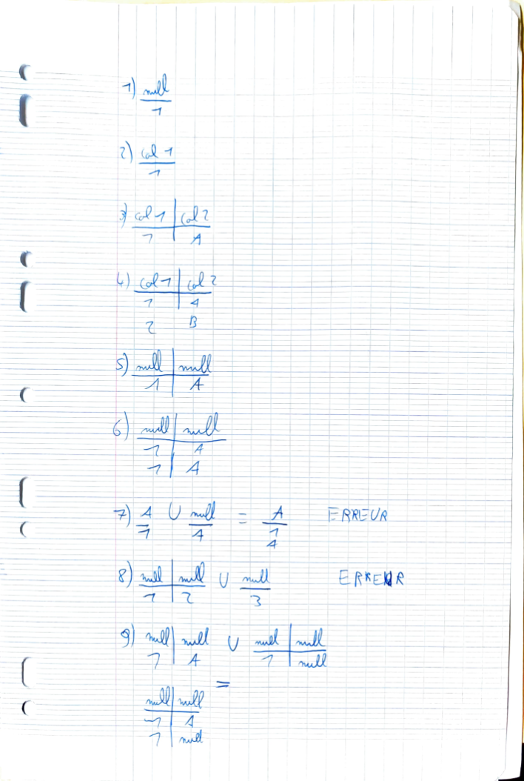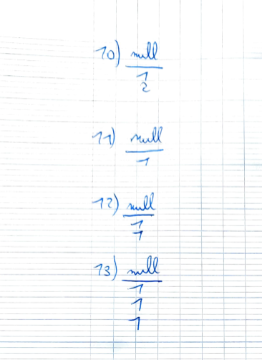

  - SELECT 1 as col1, 'A' as col2
INTERSECT
SELECT 1, 'A'

  - (SELECT 1 UNION SELECT 2 as col1)
INTERSECT
(SELECT 2 AS col2 UNION SELECT 3 col3)

  - SELECT 1 UNION ALL SELECT 1 UNION ALL SELECT 2
EXCEPT
SELECT 2
